Nursery Newsletter December 2021
That’s a Wrap!
Term 1 is complete and didn’t it go so quickly? I can’t believe we are only 8 sleeps away from Christmas Day! We have had a lot of excitement this month in nursery, role-playing in Santa’s workshop, Mrs. Claus Kitchen and making lots of Christmas crafts and baking.
The children performed their Christmas Nativity on Tuesday 15th December and it will be available to view on You Tube on Monday 20th at 7pm. Make it a ‘Big Night in’ and share your child’s achievements together. It is their T.V debut after all.
We have a little sad news to share to with you. Miss. Cunningham will be leaving us today Friday 17th December. She will not be returning after Christmas. We will miss her very much and we wish her all the very best for the future. We have no doubt she will be an asset to wherever she goes.
Thank you to all the parents who sent Christmas cards, gifts and well wishes. We have had a lovely first term getting to know you and your children and we look forward to your continued support and commitment next term. Best wishes for a very Merry Christmas and a Happy and Peaceful 2022!
Mrs. Gribben, Miss. Cunningham & Mrs. Tumilty
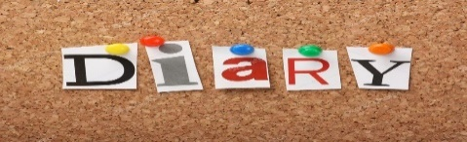

Tuesday 21st Dec: School Closes @ 11am
Wednesday 5th January: School re-opens for children
Friday7th January: Boogie Beats
Happy Birthday to our December Birthday;
Conor

