**Nursery Newsletter Sept/Oct 2021**

**Welcome**

Welcome to nursery! Thank you for all your help and support during the settling in process. It has already been a busy start to the year and all the children are now staying for lunch or dinners.

If your child has been a little upset coming into school in the morning, please feel free to telephone the office to find out how he/she has settled. If you have any queries or concerns throughout the year please contact the office and leave a message, I will get back to you.

I am really looking forward to working with you and your child over the coming year.

**Best wishes,**

**Mrs. Gribben**



**Wrap Around Care**

**Breakfast Club** will resume from Monday 4th October. More details to follow.

After-School’s Club is available for Nursery children from Wednesday 3rd November.

**After-school:** 1.30-2.35pm

**Extended After-school:** 2.35pm–5pm

Please contact Mrs. Dale in the office for more information.

**Mon 27th Sept:** Staff Development Day

(No school for children.)

**Friday 8th October:** Boogie Beats

**Tuesday 26th October:** Halloween Dress Up Day

**Wednesday 27th October:** Parent Teacher Meetings: (No school for children)

**28th Oct to 2nd Nov**- (Inclusive) Half Term Holidays

**School re-opens Wednesday 3rd November**



Happy Birthday to our Summer birthdays;

**Jude le Blevec, Robyn, Alanna, Elijah & Jude Hanna**

Happy Birthday to our September & October Birthdays;

**Cliona, Kate, Faolán & Tom**

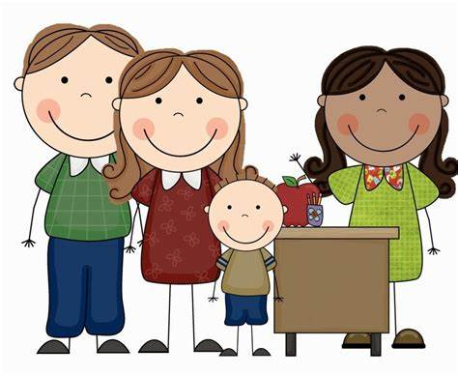

**Parent interviews**

In October Mrs. Gribben will speak to all parents about the children’s settling in experiences. As yet we are unsure of how this will present; e.g. Face to face meetings or via telephone. More information will follow.



**The Getting Ready to Learn** (GRtL) programme seeks to encourage and develop parental involvement in children's early learning to ensure maximum parental contribution at a crucial time in children's early brain development.

The project has been based on research where the findings concluded that parents would benefit from knowing more about:

* how children develop, including attachment and brain development;
* the importance of parent-child relationships for the child's development and behaviour;
* the importance of childhood education and learning; and
* the importance of healthy lifestyles and diet.

We are participating by developing a programme of support for parents around two of the four key themes offered:

* **Education Works in Pre-school**
* **Big Bedtime Read**

Our information meeting in August had some focus on raising a parent's awareness of how they can support children's learning at home through-out the pre-school year. We will continue to support this during the year. More information will follow in the coming months regarding these themes.

**Packed lunches/dinners**

Please send a sandwich/bread alternative, fruit, yogurt, **1** small treat and a drink. Grapes must be cut in half length ways. We want to avoid choking hazards. We encourage the children to eat their bread first then fruit, yogurt and then treat.