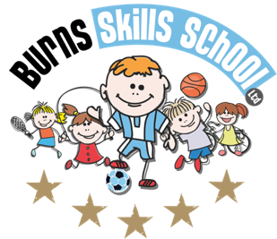
Dance

Dear Parent/Guardian
We are delighted to announce that Burns Skills School are running one of their fantastic afterschool programmes within the school grounds this year. The programme will consist of 12 weeks which will entail age appropriate educational sessions that will have a main focus of fun whilst improving each child’s technical ability.
Dates of programme:
Wednesday 15th Sept
Wednesday 22nd Sept
Wednesday 29th Sept
Wednesday 6th Oct
Wednesday 13th Oct
Wednesday 20th Oct
Wednesday 10th Nov
Wednesday 17th Nov
Wednesday 24th Nov
Wednesday 1st Dec
Wednesday 8th Dec
Wednesday 15th Dec

Primary 1, 2, & 3 (1.30pm-2.30pm each week) Primary 4, 5, 6 & 7 (2.35pm-3.35pm each week). To secure a place for your child you must complete a parental consent form CORRECTLY and return it back into school with payment of £48.00 for the attention of the secretary.

Only 20 places MAXIMUM available for each session.

Deadline for forms & payment is Friday 10th of September. This is a great opportunity for your child and certainly one not to be missed. When in attendance we would advise that all children wear appropriate clothing with a pair of trainers suitable for indoor and outdoor.

Payment options: Cash

Thanks
Aaron & Andrew
Burns Skills School

