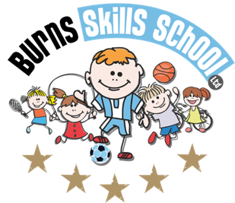
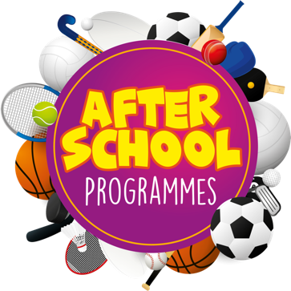
Basketball

Dear Parent/Guardian
We are delighted to announce that Burns Skills School are running one of their fantastic afterschool programmes within the school grounds this year. The programme will consist of 12 weeks which will entail age appropriate educational sessions that will have a main focus of fun whilst improving each child’s technical ability.
Dates of programme:
Tuesday 14th Sept
Tuesday 21st Sept
Tuesday 28th Sept
Tuesday 5th Oct
Tuesday 12th Oct
Tuesday 19th Oct
Tuesday 9th Nov
Tuesday 16th Nov
Tuesday 23rd Nov
Tuesday 30th Nov
Tuesday 7th Dec
Tuesday 14th Dec

Primary 1, 2, & 3 (1.30pm-2.30pm each week) Primary 4, 5, 6 & 7 (2.35pm-3.35pm each week). To secure a place for your child you must complete a parental consent form CORRECTLY and return it back into school with payment of £48.00 for the attention of the secretary.

Only 20 places MAXIMUM available for each session.

Deadline for forms & payment is Monday 13th of September. This is a great opportunity for your child and certainly one not to be missed. When in attendance we would advise that all children wear appropriate clothing with a pair of trainers suitable for indoor and outdoor.

Payment options: Cash

Thanks
Aaron & Andrew
Burns Skills School

