Please complete the questions below to apply for a position as a Digital Leader.
You can submit it by email to info@stcolmans.annaclone.ni.sch.uk or give it to Mrs Morgan by 2:35pm on Tuesday 24th September 2019.

Name: | Class:

.
Why do you want to become a digital leader?

What ICT experience do you have?

What is your favourite ICT resource (device, software, app, etc) from either school or home?

.

Give an example of something you are responsible for either at home or in school.
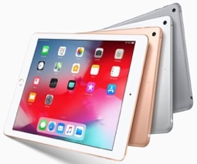
Good Luck !!
What skills do you have that would make you a good digital leader?

