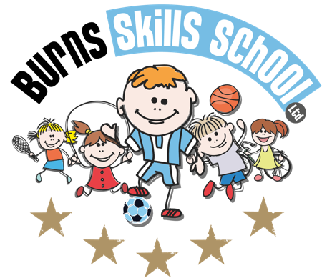
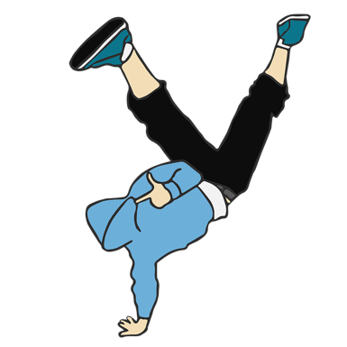
Hip Hop Dance

Dear Parent/Guardian
We are delighted to announce that Burns Skills School are running one of their fantastic afterschool programmes within the school grounds this year. The programme will consist of 10 weeks which will entail age appropriate educational sessions that will have a main focus of fun whilst improving each child’s technical ability.
Dates of programme:
Thursday 19th Sept
Thursday 26th Sept
Thursday 3rd Oct
Thursday 10th Oct
Thursday 17th Oct
Thursday 24th Oct
Thursday 7th Nov
Thursday 14th Nov
Thursday 21st Nov
Thursday 28th Nov

Primary 1, 2 & 3 (1.45pm-2.30pm each week) and Primary 4, 5, 6 & 7 (2.40pm-3.40pm each week). To secure a place for your child you must complete a parental consent form CORRECTLY and return it back into school with payment of £30.00 for the attention of the secretary. Only 20 places MAXIMUM available for each session.

Benefits of programme:

- Improves technical ability
- Enhances physical, mental and social attributes (confidence building)
- Professional coaching
- Controlled and structured physical activity
- Teaches respect for one and all
- Make new friends

Deadline for forms & payment is ___________ASAP______________________. This is a great opportunity for your child and certainly one not to be missed. When in attendance we would advise that all children wear appropriate clothing with a pair of trainers suitable for indoor and outdoor.

Payment options: Cash

Thanks
Aaron & Andrew
Burns Skills School

