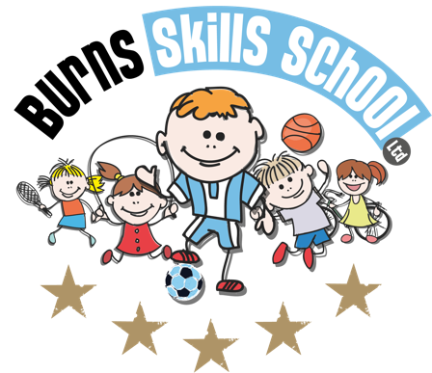
Tag Rugby

Dear Parent/Guardian
We are delighted to announce that Burns Skills School are running one of their fantastic afterschool programmes within the school grounds this year. The programme will consist of 10 weeks which will entail age appropriate educational sessions that will have a main focus of fun whilst improving each child’s technical ability.
Dates of programme:
Monday 16th Sept
Monday 30th Sept
Monday 7th Oct
Monday 14th Oct
Monday 21st Oct
Monday 4th Nov
Monday 11th Nov
Monday 18th Nov
Monday 25th Nov
Monday 2ndDec

Primary 1, 2 & 3 (1.45pm-2.30pm each week) and Primary 4, 5, 6 & 7 (2.40pm-3.40pm each week). To secure a place for your child you must complete a parental consent form CORRECTLY and return it back into school with payment of £30.00 for the attention of the secretary. Only 25 places MAXIMUM available for each session.

Benefits of programme:

- Improves technical ability
- Enhances physical, mental and social attributes (confidence building)
- Professional coaching
- Controlled and structured physical activity
- Teaches respect for one and all
- Make new friends

Deadline for forms & payment is _______ASAP_________________. This is a great opportunity for your child and certainly one not to be missed. When in attendance we would advise that all children wear appropriate clothing with a pair of trainers suitable for indoor and outdoor.

Payment options: Cash

Thanks
Aaron & Andrew
Burns Skills School

